Digital Signal Processing Lab

Labsheet 8

Name: KVNG Vikram

Sc code: sc15b148

Q1) Suppose one desires to design the following low pass filter (this is a specification of the desired response Hd(ej!).

|Hd(exp(jω))| is [1 - 0:01; 1 + 0:01]; for 0 < |ω|< 0.25pi;

[0,δ]; for |ω|> 0.3pi;

a) Obtain a complete specification of Hd(ej!) so that we have a filter with linear phase response

b) Design filters which meets the above specifications using the frequency sampling method for the cases δ = 0:01 and δ = 0:001.

(c) Plot the desired magnitude plot along with the magnitude plot of the filter that you have designed and comment on the differences.

(d) For each δ above, plot separate magnitude plots of the filters that you have obtain if you apply circular shifts of M/4 and M/2 to the h[n]. What do you observe?

(e) Suppose we need to design a filter with δ = 0.001. Using two frequency samples in a “transition band" is it possible to obtain a δ = 0:001? What should be the values of those two frequency samples? Is there a tradeoff between δ and M?

Ans.

Code:

% %Frequency sampling

% delta=0.01

% wp<=0.25\*pi

% |k|<=M/8

% ws>=0.3\*pi

% |k|>=3M/20

M=120;

for k=0:M/8

Hd(k+1)=exp(-j\*pi\*k);

end

for k=3\*M/20:17\*M/20

Hd(k+1)=0.0001;

end

for k=7\*M/8:M-1

Hd(k+1)=exp(-j\*pi\*k);

end

% for k=M/8:3\*M/20-1

Hd(M/8+2)=0.99\*exp(-j\*pi\*(M/8+1));

Hd(M/8+3)=0.3\*exp(-j\*pi\*(M/8+2));

% end

% for k=17\*M/20:7\*M/8-1

Hd(17\*M/20+2)=.8\*exp(-j\*pi\*(17\*M/20+1));

Hd(17\*M/20+3)=0.95\*exp(-j\*pi\*(17\*M/20+2));

% end

h=ifft(Hd);

f=-pi:0.01:2\*pi;

for k=0:numel(f)-1

H(k+1)=0;

for n=0:M-1;

H(k+1)=H(k+1)+h(n+1).\*exp(-j.\*n.\*f(k+1));

end

end

freqz(h)

Q2) Study what the Matlab inbuilt functions “fir2" and “firls" do. Go through the design examples which are shown in Matlab's help for these two functions.

Ans.

Code: % Example 1:

% Design a 30th-order lowpass filter and overplot the desired

% frequency response with the actual frequency response.

F = [0 0.6 0.6 1]; % Frequency breakpoints

M = [1 1 0 0]; % Magnitude breakpoints

B = fir2(30,F,M); % Frequency sampling-based FIR filter design

[h,w] = freqz(B,1,128); % Frequency response of filter

figure (1);

plot(F,M,w/pi,abs(h))

legend('Ideal','fir2 Designed')

title('Comparison of Frequency Response Magnitudes')

h=firls(30,[0 .1 .2 .5]\*2,[1 1 0 0]);

fvtool(h);

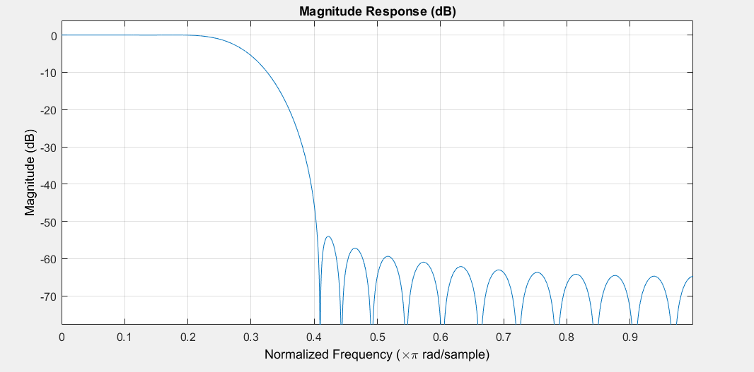Output:

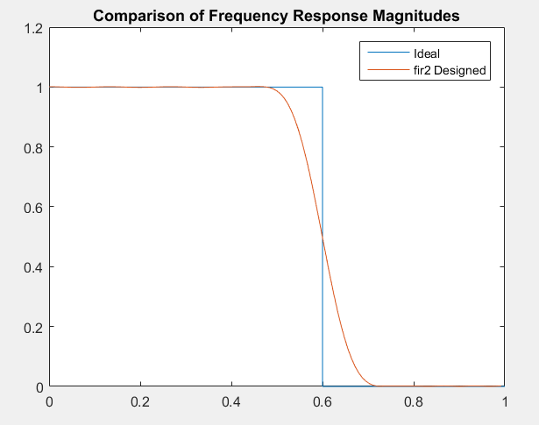

Q3) Study what the Matlab inbuilt function “rpm" (or “remez") does. Use firpm to design a linear phase equiripple filter meeting the requirements in Task 1.

Ans.

Firpm: firpm Parks-McClellan optimal equiripple FIR filter design. B=firpm(N,F,A) returns a length N+1 linear phase (real, symmetric coefficients) FIR filter which has the best approximation to the desired frequency response described by F and A in the minimax sense. F is a vector of frequency band edges in pairs, in ascending order between 0 and 1. 1 corresponds to the Nyquist frequency or half the sampling frequency. At least one frequency band must have a non-zero width. A is a real vector the same size as F which specifies the desired amplitude of the frequency response of the resultant filter B.

Code:

h=firpm(30,[0 .25 .3 1],[1 0.99 0.01 0]);

fvtool(h);

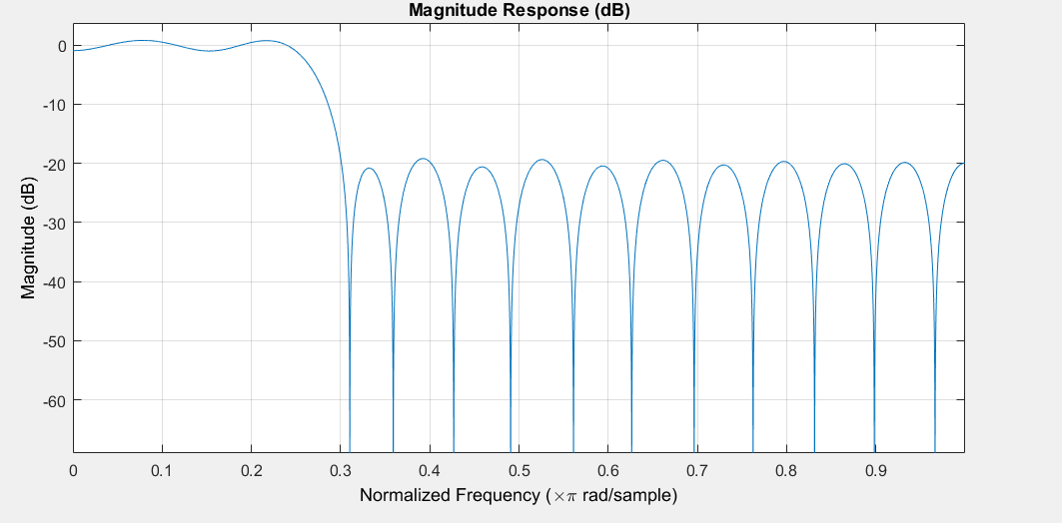Output:

Q4) Matlab also provides filter design tools such as “filterbuilder" and “fdatool". Explore how these tools can be used to design FIR filters.

Ans.

The tools are viewed and understood.